

APS Supervisor Core:
Supervising Complex
Cases

Instructor Led Training

Participant Manual
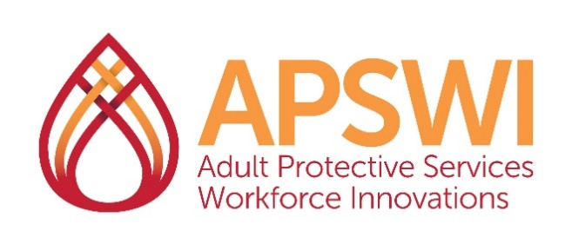
The Academy for Professional Excellence is a project of the San Diego State University School of Social Work

Funding Sources


This training was developed by the Academy for Professional Excellence, with funding from the California Department of Social Services, Adult Programs Division.
Curriculum Developer, Original 2022 (Revisions), 2026
Brenda Wilson-Codispoti, LCSW

©2026 Academy for Professional Excellence. All rights reserved.

Introduction
We are pleased to welcome you to APS Supervisor Core: Supervising Complex Cases, Participant Manual, developed by Adult Protective Services Workforce Innovations (APSWI), a program of the Academy for Professional Excellence under a grant from the California Department of Social Services, Adult Programs Division.
The Academy for Professional Excellence, a project of San Diego State University School of Social Work, was established in 1996 with the goal of revolutionizing the way people work to ensure the world is a healthier place. Our services integrate culturally responsive and recovery-oriented practices into our daily work to promote healing and healthy relationships. Providing around 70,000 learning experiences to health and human service professionals annually, the Academy provides a variety of workforce development solutions in Southern California and beyond. With five programs, three divisions and over 100 staff, the Academy’s mission is to provide exceptional learning and development experiences for the transformation of individuals, organizations and communities.
APSWI is a program of the Academy for Professional Excellence. APSWI is designed to provide competency-based, multidisciplinary training to Adult Protective Services professionals and their partners. APSWI’s overarching goal is the professionalization of Adult Protective Services professionals to ensure that abused and vulnerable older adults and adults with disabilities receive high quality, effective interventions and services.
APSWI partners with state and national organizations and experts in the older adult and adults with disabilities professions to empower APS professionals and those they serve to live safely, peacefully and in a world that is free from abuse and neglect.
APSWI’s partners include:
- National Adult Protective Services Association (NAPSA) Education Committee and the National Adult Protective Services Training Center (NATC)
- California Department of Social Services (CDSS), Adult Programs Division
- County Welfare Directors Association of California (CWDA), Protective Services Operations Committee (PSOC)
- California’s Curriculum Advisory Committee (CAC)

Acknowledgements
This training is the result of a collaborative effort between Adult Protective Services administrators, supervisors, staff development officers and workers across the state and the nation; professional educators; and the Academy for Professional Excellence staff members. APSWI would like to thank the following individuals and agencies:

Agencies
California Department of Social Services, Adult Programs Division
Arizona Department of Economic Security, DAAS-Adult Protective Services
National Adult Protective Services Association

Committees:
National Adult Protective Services Association Education Committee
Supervisor Curriculum Advisory Committee for the original version

Curriculum Developer
Brenda Wilson-Codispoti, LCSW

Table of Contents
Funding Sources 1
Introduction 2
Acknowledgements 3
Table of Contents 4
Executive Summary 6
Course Outline 8
Welcome, Introductions and Course Overview 11
Slide #1: Title Slide 11
Slide #2: About the Academy and APSWI 11
Slide #3: Purpose of Land Acknowledgement 12
Slide #4: Land Acknowledgement 12
Slide #5: Housekeeping & Course Overview 13
Slide #6: Learning Objectives 13
Slide #7: Introductions and Connection 14
What is a Complex Case? 14
Slide #8: Complex APS Cases 14
Slide #9: Examples of Complex APS Cases 15
Slide #10: Supervisory Tasks 15
The Value of Risk Assessment 16
Slide #11: Polling Questions 16
Slide #12: What is a Risk Assessment 16
Slide #13: How do Risk Assessments Support APS Professionals? 17
Slide #14: How do Risk Assessments Support APS Supervisors? 17
Risk Assessment Tools and Strategies 18
Slide #15: The 3 S’s of Risk Assessment 18
Slide #16: Ready-Set-Go! 5 Minute Coaching Questions 18
Handout: Risk Assessment Chart 19
Handout: Ready-Set-Go! 5-Minute Coaching Questions 22
Slide #17: Differences in Service Planning 23
Slide #18: People Who Have Accepted APS Services or Those That Need Involuntary Interventions 23
Slide #19: Service Planning for Voluntary and Safety Required Situations 24
Slide #20: The 3 Phases of Risk Assessment 24
Handout: The 3 Phases of Risk Assessment 25
Handout: Christoph and Freida’s Case Scenario 27
Slide #21: Small Group Activity 28
Working Together: Consultation, Collaboration, and Multidisciplinary Teams 28
Slide #22: What is a Multidisciplinary Team? 28
Slide #23: Examples of MDTs 29
Slide #24: Informal Supports and Community Providers 29
Slide #25: Let’s Practice 30
Slide #26: Supervisor Case Consultation 30
Case Closure and Quality Assurance 31
Slide #27: Planning for Case Closure 31
Slide #28: Reassessments and Case Closure 31
Handout: Checklist for Case Closure Questions to Consider 32
Wrap Up and Evaluations 34
Slide #29: Supervising Complex Cases TOL 34
Slide #30: Workshop Summary and Questions 34
Handout- Transfer of Learning 35
Slide #31: PIE 36
Slide #32: Evaluations 37
Slide #33: Thank You! 37
References and Resources 38

Executive Summary
Course Title: APS Supervisor Core: Supervising Complex Cases Instructor-Led Training.
Course Description: Adult Protective Services Supervisors navigate a wide range of responsibilities each day, including guiding staff through investigations, case planning, and the management of extraordinarily complex situations. These situations often require careful analysis, thoughtful oversight, and a steady supervisory presence to support staff in making sound decisions.
In this interactive training, you will explore examples of complex cases and examine how supervisory leadership shapes the quality and direction of APS investigations. You will learn about tools, best practices, and strategies to help your staff manage challenging situations while adhering to agency policies, strengthening quality assurance, and safeguarding the well‑being of adults in our communities.

Instructor Led Training:
This course is designed to be facilitated virtually or in-person
Course Requirements:
None
Intended Audience:
This workshop is intended for new supervisors, APS professionals that may be wanting to promote, or experienced staff who may require a refresher.

Learning Objectives:
Upon completion of this training, participants will be able to:
- Explain what a complex case means in the APS Supervisor role.
- Identify tools and strategies that APS Supervisors can use to guide supervisory sessions with their staff.
- Explain the need for collaboration and coordination with community providers and the value and use of multi-disciplinary teams.
- Establish guidelines and identify tools that APS supervisors can utilize to support quality assurance with case closure.

Course Outline
CONTENT | MATERIALS | TIME
WELCOME, INTRODUCTIONS, COURSE OVERVIEW | PPT slides 1-7 | Total: 20 minutes
Land Acknowledgment | N/An/a | N/An/a
Housekeeping and Learning Objectives | N/An/a | N/An/a
Trainer/s Introduction Activity: The Three F’s  (large group) | N/An/a | 10 minutes
WHAT IS A COMPLEX CASE | PPT slides 8-10 | Total: 30 minutes
Activity: What is a Complex Case and My Role  (small group) | N/An/a | 20-25 minutes
Examples of Complex Cases | N/An/a | N/An/a
Supervisory Tasks | N/An/a | N/An/a
THE VALUE OF RISK ASSESSMENTS | PPT slides 11-14 | Total: 15 minutes
Activity: How Risk Assessments Support APS Professionals and Supervisors (Individual) | Polling Ability | 5 minutes5 minutes
What is a Risk Assessment? | N/An/a | N/An/a
How do Risk Assessments Support APS Professionals | N/An/a | N/An/a
How do Risk Assessments Support APS Supervisors’
RISK ASSESSMENTS TOOLS AND STRATEGIES | PPT slides 15-24 | Total: 55 minutes
The 3 S’s of Risk assessment | N/A | N/A
Ready-Set-Go! 5 Minute Coaching Questions | N/A | N/A
Voluntary and Involuntary Service Planning | N/A | N/A
Phases of Risk Assessment | N/A | N/A
Activity: A Complex Case and the Supervisor’s Role in Case Consultation  (small group) | Handout: Christoph and Freida Case Scenario | 20 minutes
WORKING TOGETHER: CONSULTATION, COLLABORATION, AND MULTIDISCIPLINARY TEAMS | PPT slides 25-29 | Total: 45 minutes
Multidisciplinary Teams | N/A | N/A
Informal Supports and Community Providers | N/A | N/A
Activity: Review a Case Scenario  (individual and large group) | Handout: Christoph and Fredia Case Scenario Identify Resources and Referrals | 10 minutes
Activity: Supervisor Consultation on a Complex Case  (Small group) | Video clip | 20 minutes
CASE CLOSURE AND QUALITY ASSURANCE | PPT slides 30-32 | Total: 15 minutes
Planning for Case Closure | N/A | N/A
Reassessments and Case Closure | N/A | N/A
Supervisor Transfer of Learning | N/A | N/A
WRAP UP | PPT slides 33-36 | Total: 20 minutes
Summary and Key Concepts | N/A | N/A
Activity: Individual PIE | N/A | N/A
Evaluations | N/A | N/A
TOTAL TIME (excluding breaks) | N/A | Total 3.5 hours

Welcome, Introductions and Course Overview

Slide #1: Title Slide
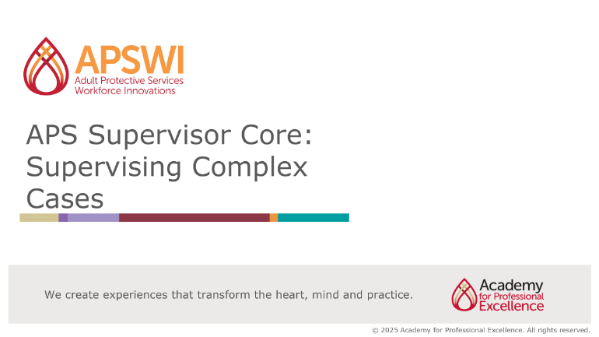

Notes

Slide #2: About the Academy and APSWI
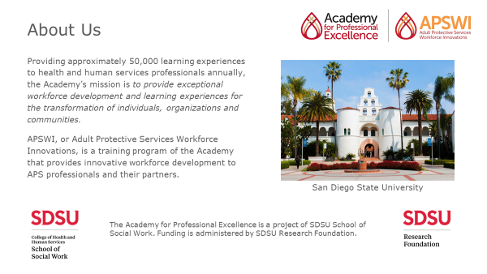

Notes

Slide #3: Purpose of Land Acknowledgement
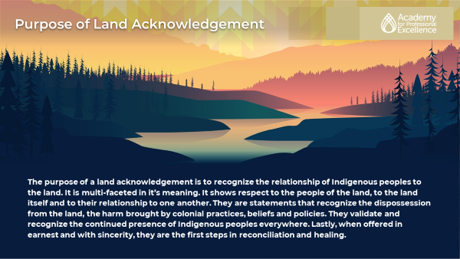

Notes

Slide #4: Land Acknowledgement
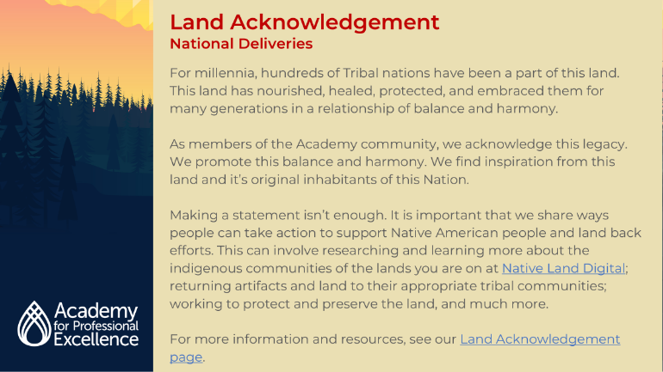

Notes

Slide #5: Housekeeping & Course Overview
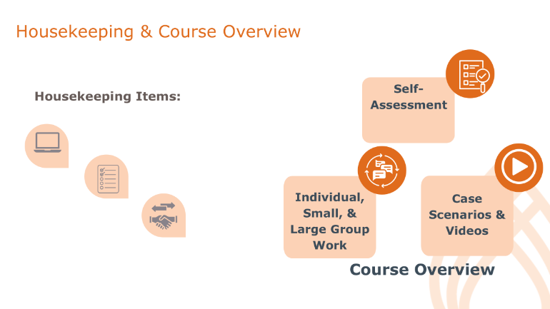

Notes

Slide #6: Learning Objectives
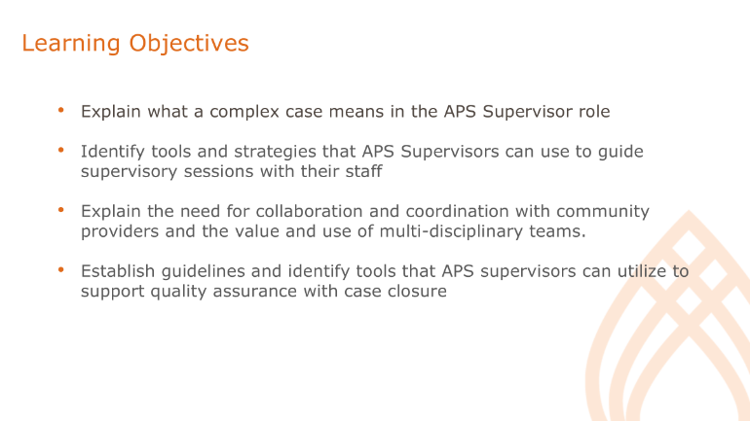

Notes

Slide #7: Introductions and Connection
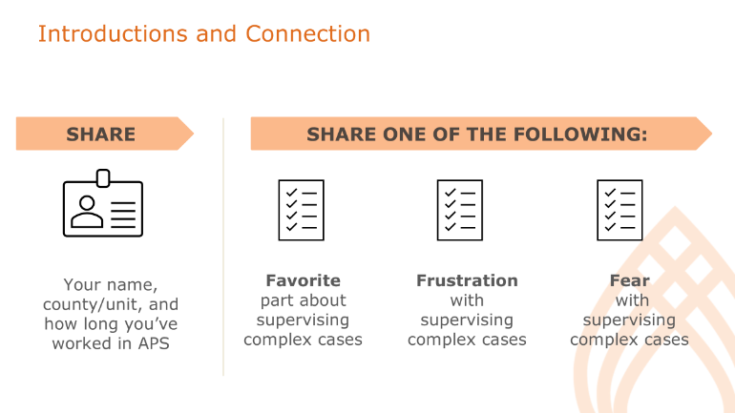

Notes

What is a Complex Case?

Slide #8: Complex APS Cases
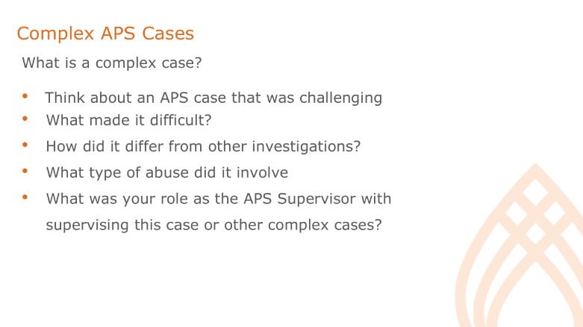

Notes

Slide #9: Examples of Complex APS Cases
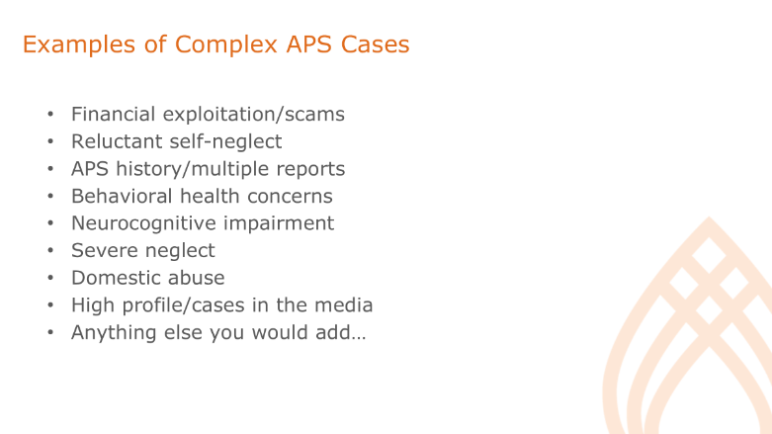

Notes

Slide #10: Supervisory Tasks
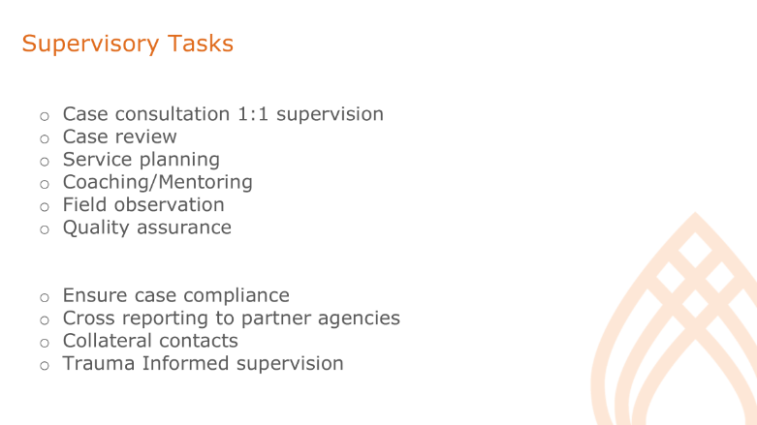

Notes

The Value of Risk Assessment

Slide #11: Polling Questions
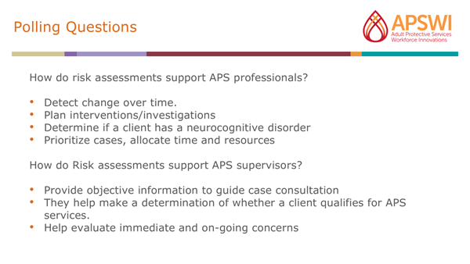

Notes

Slide #12: What is a Risk Assessment
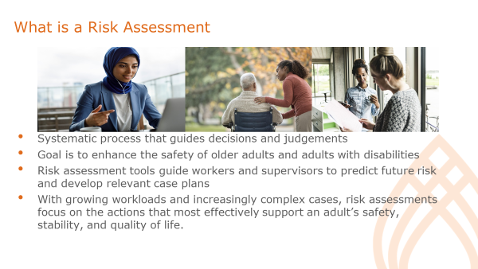

Notes

Slide #13: How do Risk Assessments Support APS Professionals?
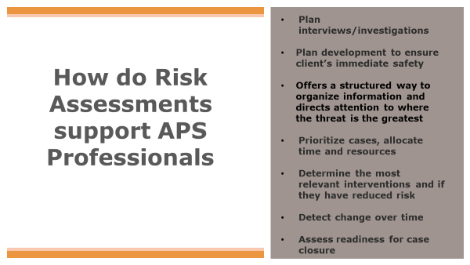

Notes

Slide #14: How do Risk Assessments Support APS Supervisors?
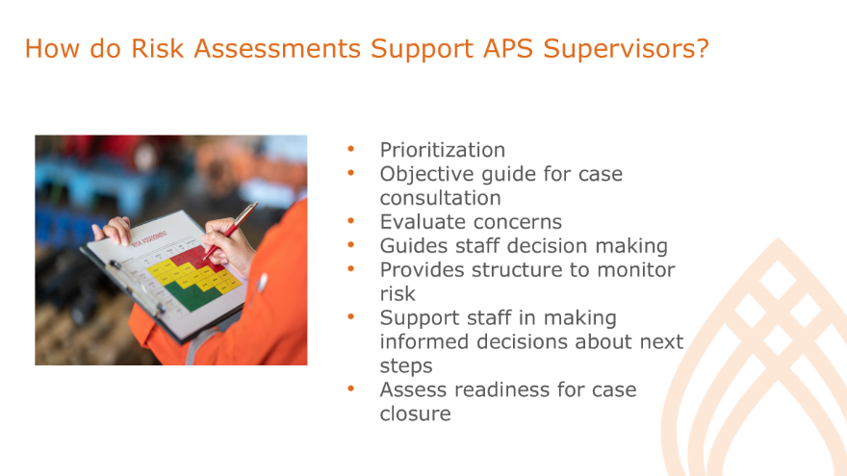

Notes

Risk Assessment Tools and Strategies

Slide #15: The 3 S’s of Risk Assessment
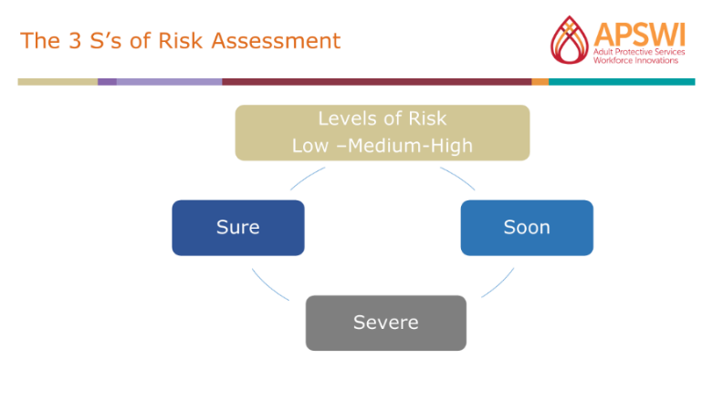

Notes

Slide #16: Ready-Set-Go! 5 Minute Coaching Questions
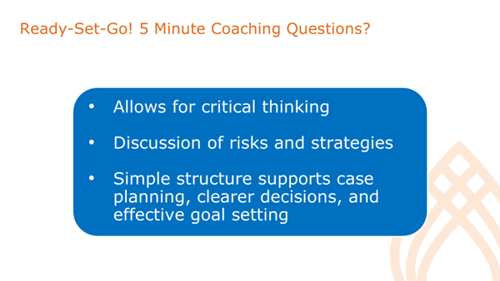
Notes

Handout: Risk Assessment Chart
Directions: Using a current case, complete the risk assessment chart based on your observations and the information from the case.
For each Risk Factor that you identify:
- List the apparent risk next to the # in the Risk Factor column.
  - Circle or highlight whether you find that risk to be low, medium or high.
  - Using the 3 S’s note how Soon might the client be harmed, how Severe might they be harmed and how Sure are you that the harm will occur (i.e. the likelihood).
    - Make sure to include why you believe that to be true.
- Identify and discuss any observable signs that indicate that risk may be present in the Risk Indicators column.
- Provide any history and context around this particular risk in the Global Assessment column.
- Note any factors such as the client’s strengths, motivation, and support network in the Factors that Mitigate the Risk column.
- Identify services for each risk in the Service Plan column.
RISK FACTORS  (Conditions which put a person at risk of harm) | RISK INDICATORS  (Observable signs that indicate that risk may be present) | GLOBAL ASSESSMENT  (History and context around this particular risk) | FACTORS THAT MITIGATE THE RISK  (Client’s strengths, motivation, support network) | SERVICE PLAN  (Identify services that might be of help and follow up if connections were made.)
#1.  - Soon  - Severe  - Sure  Based on the 3 S’s, the level of risk is: Low, Med, or High? | N/A | N/A | N/A | N/A
#2.  - Soon  - Severe  - Sure  Based on the 3 S’s, the level of risk is: Low, Med, or High? | N/A | N/A | N/A | N/A
#3.  - Soon  - Severe  - Sure  Based on the 3 S’s, the level of risk is: Low, Med, or High? | N/A | N/A | N/A | N/A
#4.  - Soon  - Severe  - Sure  Based on the 3 S’s, the level of risk is: Low, Med, or High? | N/A | N/A | N/A | N/A
#5.  - Soon  - Severe  - Sure  Based on the 3 S’s, the level of risk is: Low, Med, or High? | N/A | N/A | N/A | N/A

Handout: Ready-Set-Go! 5-Minute Coaching Questions
- What options do you see regarding this situation?

- What do you see as a challenge?

- What are your thoughts about the best way to approach this?

- What might get in your way?

- What do you think is the next step?

- How can I support you?

- When can I check back with you?

Slide #17: Differences in Service Planning
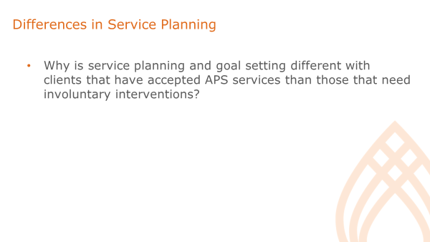

Notes

Slide #18: People Who Have Accepted APS Services or Those That Need Involuntary Interventions
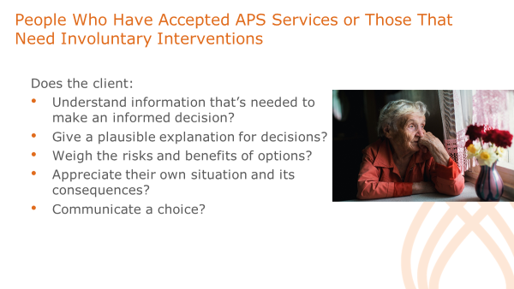

Notes

Slide #19: Service Planning for Voluntary and Safety Required Situations
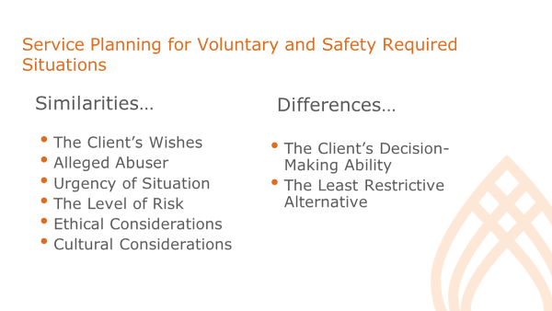

Notes

Slide #20: The 3 Phases of Risk Assessment
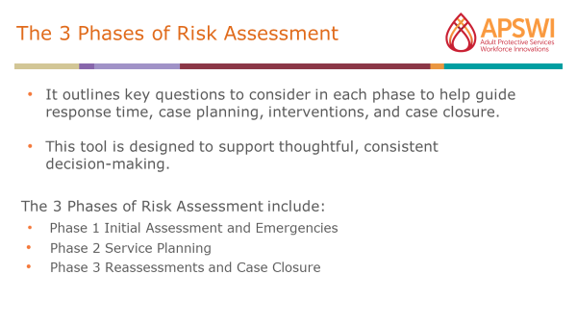

Notes

Handout: The 3 Phases of Risk Assessment

Phase 1: Initial Assessment and Emergencies
Helps workers decide:
- Whether to investigate a report - Does the situation meet the criteria of a client being at risk?
- How quickly an investigation should be initiated - Do you need to go out immediately?
- Are older/dependent adults in immediate danger - e.g. Are they alone and unable to manage? How soon might they come to harm?
- Why are they calling now? Did something just happen?
- Does the client understand what’s going on? Is the client’s neurocognitive status affected to the point they do not understand they are at risk?
- Is the client capable of making decisions?
- What’s at risk (life, health, property)?
- What are the consequences of delay? How severe might the harm be?
- What emergency or protective measures and services are needed?
- What is the likelihood (or how sure are you) that they will be harmed without intervention?

Phase 2: Service Planning
Matching Services to Types and Levels of Risk:
- Are protective services needed on an ongoing basis to prevent future harm or abuse?
- How likely is it that harm or abuse will occur?
- What factors make it likely that abuse will occur in the future?
- Factors to consider:
  - Do abusers pose on-going risk?
  - What factors mitigate risk (e.g. clients’ strengths and resources)?
  - Are informal supports available to help?
  - How do older adults view the situation? What do they want to do about it? Are they capable of making choices and assisting with care plans?

Phase 3: Reassessments and Case Closure
- Has risk changed over time? Is the client at higher or lower risk?
- What accounts for the changes? Are new issues emerging? Are perpetrators out of the picture? Have threats been removed? Have interventions reduced risk? Has the client changed his or her mind about accepting services?
- Are changes to the care plan needed? What preventative measures are needed?
- What is the likelihood that the situation will recur?

Handout: Christoph and Freida’s Case Scenario
Christoph and Frieda are a married couple who are retired and live in a house they own. Christoph is 89 and Frieda is 93. They emigrated from Germany in the 1950’s with their son who passed away approximately two years ago. Both are fluent in German and English.
Christoph was diagnosed with Alzheimer’s Disease approximately three years ago but was managing well with assistance from Frieda and his son, prior to his death. Frieda has been having Transient Ischemic Attacks (TIAs or mini strokes) and has not been to the doctor since the TIAs started, approximately one year ago.
Recently, Frieda received an eviction notice and ran outside screaming. A neighbor noticed and attempted to help her. The neighbor went through some mail and learned that the couple were being evicted due to being one year behind with HOA fees.
The reporting party (RP) states the house has a very strong odor of urine. The house is in hoarded condition with papers, bills, kitchen items, books, and more collected all over the house. There is rotting food in the kitchen and the refrigerator is filled with rotting food and not working. There are several notices that the utilities will be shut off for non-payment. When the reporting party (RP) asked the couple about this, Christoph is pleasant, but does not appear to follow the conservation well, and continually states that “Frieda takes care of me and everything.” Frieda is guarded but later admits that she has not been paying bills and is frequently not feeling well. The couple states they have no family and do not want “government assistance.”

Instructions:
- Use the 3S’s of Risk Handout and identify 1 risk factor to use to fill out each column of the template (e.g. Risk Factors, Risk Indicators, Global Assessment, Factors that Mitigate Risk, Services Plan).
- Review the Ready-Set-Go! 5-Minute Coaching Questions Handout and as a group decide what “Ready-Set-Go! 5-Minute Coaching Questions” that you would use with the assigned staff to this case scenario and/or other open-ended questions, or reflections to assist the APS professional with critically thinking, exploring case concerns, and engaging in case planning with the APS Professional.

Slide #21: Small Group Activity
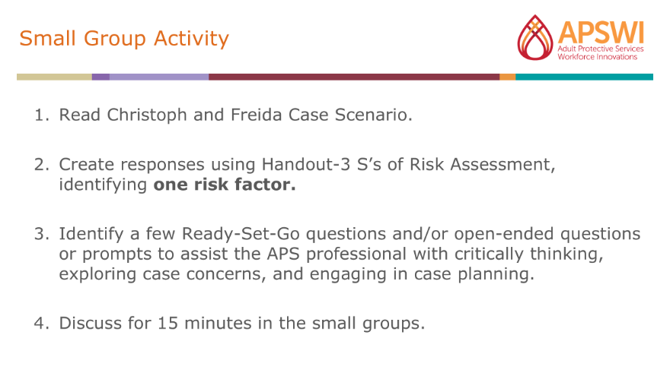

Notes

Working Together: Consultation, Collaboration, and Multidisciplinary Teams

Slide #22: What is a Multidisciplinary Team?
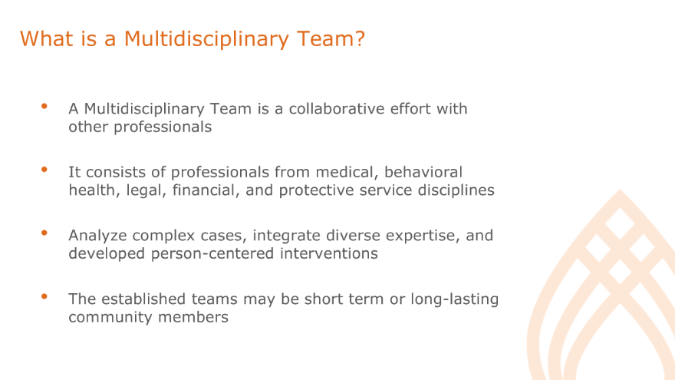

Notes

Slide #23: Examples of MDTs
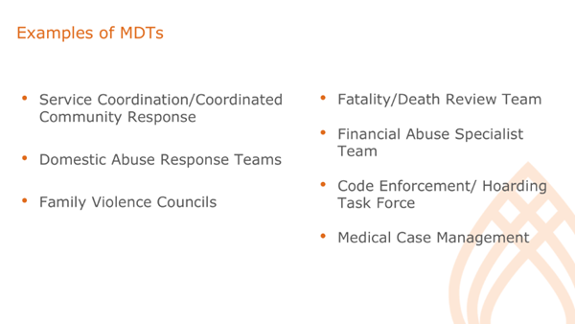

Notes

Slide #24: Informal Supports and Community Providers
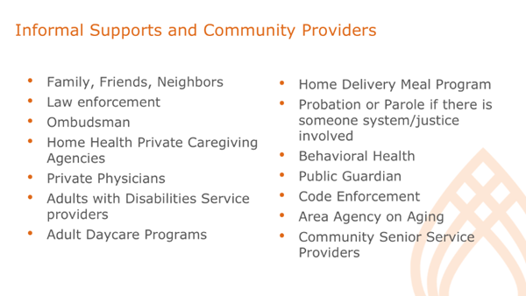

Notes

Slide #25: Let’s Practice
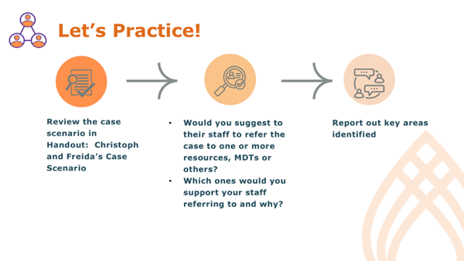

Notes

Slide #26: Supervisor Case Consultation
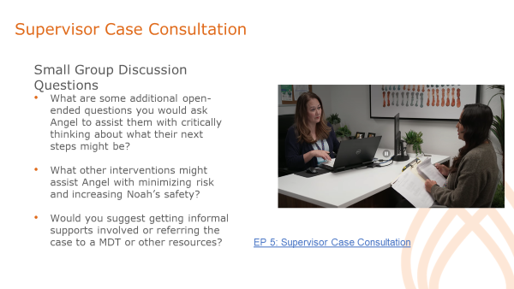

Notes

Case Closure and Quality Assurance

Slide #27: Planning for Case Closure
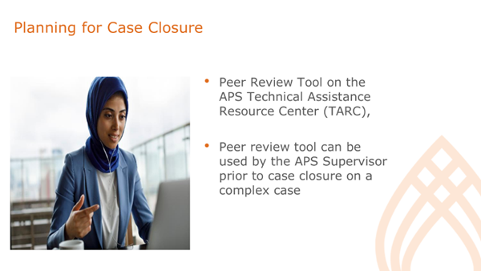

Notes

Slide #28: Reassessments and Case Closure
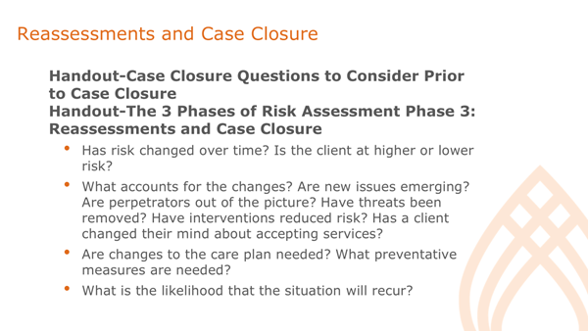

Notes

Handout: Checklist for Case Closure Questions to Consider

- Has the protective issue been addressed or resolved? If the protective issue has not been resolved, was it due to the client’s choice to decline services or interventions? Are the client’s choices well documented?

- If the client chose not to engage in services, has the client’s capacity to act as their own decision maker been assessed/evaluated/determined, either by the APS Professional or by a physician, psychologist, geriatric specialist, neurologist, or licensed mental health clinician?

- Was the client’s capacity/mental status assessed in general, whether or not the client chose to engage in services? If indicated per agency guidelines, was a dementia/neurocognitive disorder screening tool used?

- Was the client assessed for suicidal/homicidal ideation? Were appropriate mental health interventions and/or consultations sought if suicidal and/or homicidal ideation was identified as a concern?

- Were any firearms/weapons identified to be in the home and if so, has this been sufficiently addressed per agency guidelines?

- Were required demographic and SOGI (sexual orientation and gender identity) questions asked and updated in demographics portion of the case record?

- Did all necessary collaboration with community partners occur?

- Was the reporting party contacted (or attempts made to contact)?

- Was pertinent information gathered from collateral contacts and other involved parties?

- Was there a review of external documentation, such as legal, financial, and medical records?

- Was there an attempt to connect the client with supportive resources, services/programs, and/or longer-term case management?

- Were all service plan goals met, and if goals were not met, is this explained in the documentation?

- Is case documentation complete?

- Were all required cross-reports made? (Such as cross-reporting confirmed abuse to law enforcement, etc.)

- Are the case findings accurate, in alignment with Consistency In Findings standards, and well supported in the documentation?

- Were all documents imported into the record keeping system per agency protocols?

Wrap Up and Evaluations

Slide #29: Supervising Complex Cases TOL
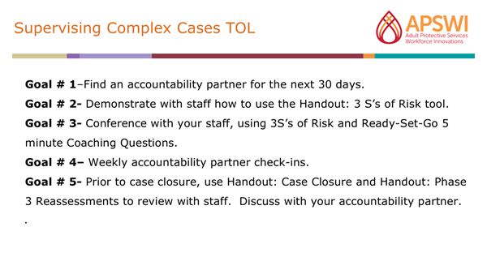

Notes:

Slide #30: Workshop Summary and Questions
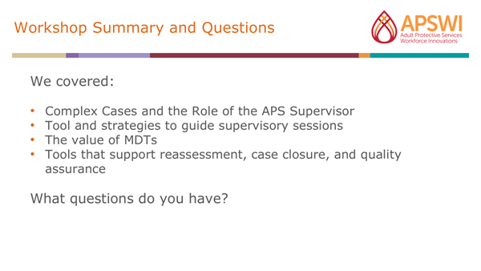

Notes:

Handout- Transfer of Learning
Instructions: In the next 30 days, complete the five goals.

- Goal # 1 – Reach out to one of your peers this week to be your accountability partner for the next 30 days.

- Goal # 2 - Demonstrate how to use the Handout: 3 S’s of Risk tool or another preferred risk assessment tool you use and with your staff in a conference prior to a pre-initial or post initial face to face contact visit on a complex case.

- Goal # 3- Conference with your staff after their face-to-face visit on the case. Discuss the information they gathered, the findings, and risks they identified using the 3 S’s of Risk. Use the Handout: Ready-Set-Go-5-minute Coaching Questions or other open-ended questions to further explore and support staff in using their critical thinking skills for the case planning process.

- Goal # 4 - Touch base with your accountability partner once a week to provide feedback on your staff’s use of the 3 S’s of Risk and your use of coaching/open-ended questions in your conferences.

Goal # 5 - Use Handout: Checklist for Case Closure and Handout: Phase 3 Reassessments and Case Closure to review the 2 complex cases prior to case closure. Provide feedback to your accountability partner.

Slide #31: PIE
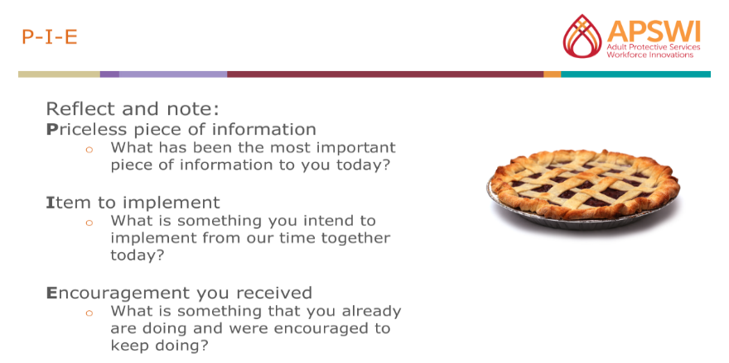

Notes:

- Priceless: What has been the most important piece of information to you today?

- Item to Implement: What is something you intend to implement from our time together?

- Encouragement you received: What is something that you already are doing and were encouraged to keep doing?

Slide #32: Evaluations
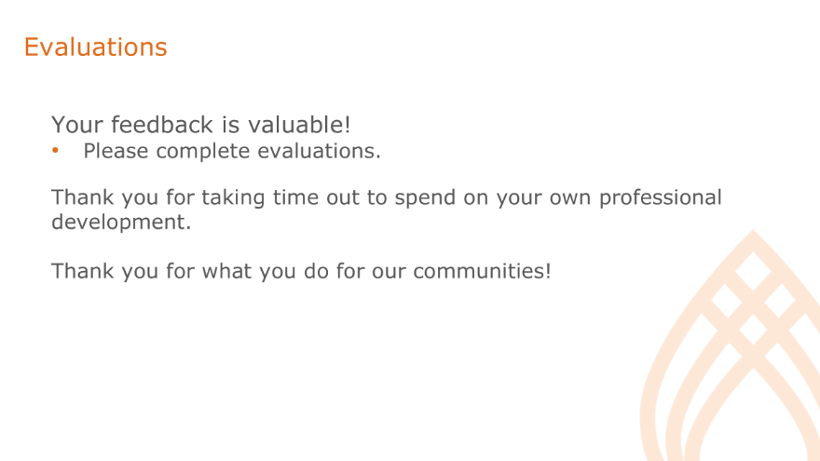

Notes:

Slide #33: Thank You!
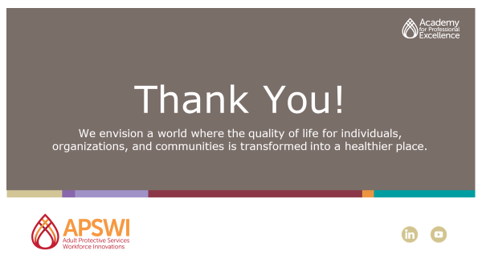

Notes:

References and Resources
Brandl, B., Bitondo Dyer, C., Heisler, C.J., Marlatt Otto, J., Stiegel, A.A., and Thomas, R. W. (2007) Elder abuse detection and intervention. New York: Springer Publishing Company, LLC.
Brandl, B and Thomas, R. (2006). Enhancing victim safety through
collaboration. Care Management Journals, Summer 2006, 7 (2). 64-72. (9).
Capehart, A. (2020, January 31). Quality Assurance Spotlight: Peer Review. Administration for Community Living, APS Technical Assistance Resource Center. Retrieved May, 26, 2022 from https://apstarc.acl.gov/APS-Blog/January-31-2020.aspx
Dyer, C. B., Kelly, P. A., Pavlik, V. N., Lee, J., Doody, R. S., Regev, T., et al. (2006). The making of a self-neglect severity scale. Journal of Elder Abuse & Neglect, 18(4), 13-23. https://www.ncbi.nlm.nih.gov/pmc/articles/PMC2743305/
Ernst, JS., Ramsey-Klawsnik, H., Schillerstrom, JE., Dayton, C., Mixson, P., & Counihan, M. (2014). Informing evidence-based practice: a review of research analyzing adult protective services data. Journal of Elder Abuse & Neglect, 26(5), 458-94.
Gawande, A.A. (2009). The checklist manifesto: How to get things done right. New York: Metropolitan Books.
Henderson, L. (n.d.). The adult protective services tool for risk interventions and outcomes: The APS- TRIO. PowerPoint presentation. Retrieved May 14, 2015, from A Developmental Model for Understanding Adult Protective Services: Risk Assessment Curve (ventura.org).
Lachs & Pillemer, 2004; National Research Council, 2003; Pillemer & Finkelhor, 1988; Paveza et al,1992). A vast majority of elder abuse reports occur in domestic settings (National Center on Elder Abuse, 2004).
Mosqueda, L., Burnight, K., & Liao, S. (2020). Elder abuse multidisciplinary teams: A review and model for practice. National Center on Elder Abuse.
Park, K., Johnson, K., Flasch, S., & Bogie, A. (2010). Structuring decisions in Adult Protective Services. Madison WI: National Council on Crime and Delinquency. Retrieved March 31, 2022, from https://www.evidentchange.org/sites/default/files/publication_pdf/focus-adultprotectiveservices.pdf
Poertner, J. (2013) Encyclopedia of Social Work: Management: Quality Assurance: Retrieved from Oxford Reference Encyclopedias: Quality Assurance | Encyclopedia of Social Work (oxfordre.com).
Wigelsworth, A.M. (2014) Variability in Findings from Adult Protective Services Investigations of Elder Abuse in California. Journal of evidence-informed social work.


Our Why: Revolutionize the way people work to ensure the world is a healthier place

theacademy.sdsu.edu
6505 Alvarado Road, Suite 107; San Diego, CA 92120 (619) 594-3546

